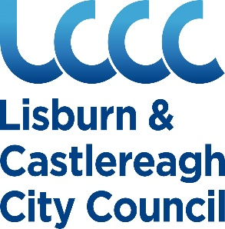

**Product Safety Advice**

**for Market & Fairs Traders**

**For further advice and information on supplying safe goods contact the Environmental Health Department on**

**Phone:** 028 9244 7300

**Email:** [ehealth@lisburncastlereagh.gov.uk](mailto:ehealth@lisburncastlereagh.gov.uk)

**Website:** [www.lisburncastlereagh.gov.uk](http://www.lisburncastlereagh.gov.uk)

**About Us**

Officers from the Environmental Health Department have a role to ensure consumers are protected against potential risks from unsafe goods manufactured or sold within our area. We

* carry out programmed inspections of premises to ensure goods on sale are safe
* provide advice to suppliers about legislation, and
* sample consumer goods to ensure they meet required standards of safety
* investigate complaints of unsafe consumer goods

**Your responsibilities**

If you sell products to the public, you have a legal duty to ensure they are safe and meet relevant regulations. A product is safe if it presents no risk (or almost no risk) to consumers if they use the product in the intended way. These duties apply to small scale home-based suppliers in the same way they apply to larger scale manufacturers and suppliers.

**Producer responsibilities**

If you are a producer (importer, manufacturer, own-brander, re-conditioner, etc) then you are responsible for ensuring your products are safe and carry adequate instructions and warnings for consumers to use them safely.

You must allow for traceability by indicating on the product or its packaging, where reasonable to do so your name and address, and the product reference or, where applicable, the batch of products to which it belongs.

Once in the supply chain, a producer is also required to have measures in place to identify any risks or issues arising from a product's use so that urgent action can be taken for example including issuing a recall.

**Distributor responsibilities**

A distributor purchases goods from a manufacturer, importer, or another distributor and sells those goods to customers - for example, in a wholesaler's or retail shop.

You must not offer products for sale if you do not know whether they are safe or not. This means you have to know about product requirements, so that you can check whether your product meets the product safety requirements - called conformity. As a distributor you must be able to prove that you have done your utmost to check a product's conformity.

You are required to monitor the safety of the products that you supply, passing on information to the producer and cooperating with them if they advise you of a problem.

From 13 December 2024, new product safety rules will apply when the EU GPSR regulation comes into force. For example, it must be clear where your product comes from (traceability).

To make sure the products you sell are safe, you should have systems in place to check:

* meet relevant laws
* have instructions for putting the product together safely and using it safely
* have adequate markings and warnings
* are not damaged
* are tested to make sure they meet all safety standards that apply
* have accessible records of any testing
* can be recalled if they are found to be dangerous; and
* are sold in line with any restrictions that apply

**Product Safety Requirements**

This leaflet contains pictures and information on some products which have recently been identified as having safety issues. You must only sell safe products and refrain from selling any products that have been identified as unsafe. Sources of further guidance on product safety have been included at the end of this guidance document.

**Toys**

Toys are defined as any products designed or intended (whether or not exclusively) for use in play for children under 14 years old. They must be labelled as follows:

* A stuffed animal toy giraffe

  Description automatically generatedThe name and address of the manufacturer or importer.
* ****It must bear a CE or CE and UKNI Mark – this is a declaration by the manufacturer that the toy complies with all EU safety rules. The CE Mark must be in the following format and be at least 5mm high and legible.
* Warnings and instructions for use - usually on the packaging or on an accompanying leaflet eg “Not suitable for children under 36 months due to presence of small parts”.

You should also check incoming stock to see if it is physically safe – i.e. check it does not have sharp edges. When you have reason to believe a toy is unsafe and presents a risk - for example, you receive a complaint that a toy has injured a child - you must inform the Environmental Health Department and your supplier of the risk and withdraw the toy from sale, if appropriate.

**Products with batteries and small parts**

Button batteries, in particular powerful lithium coin cell batteries, can badly hurt or kill a small child if they swallow one and it gets stuck in their oesophagus. Button batteries are used in an increasingly wide range of toys, novelty items, gadgets and other everyday objects found around the house such as remote controls, kitchen or bathroom scales, and gaming headsets.

Button batteries react with saliva to make caustic soda, which is used to unblock drains. If a child swallows a button battery and it gets stuck it may cause internal bleeding and can kill. Surgeons at Great Ormond Street Hospital report seeing one child a month with corrosive burns caused by button batteries and at least two children a year have died in the UK.

Larger lithium batteries are the most dangerous. They are about the same size as a 5p piece. Smaller batteries can also be put into places like ears and noses. There is also a risk of children choking on small parts.

Check products before you sell them. It is a legal requirement that battery compartments of toys are secured eg using screws.

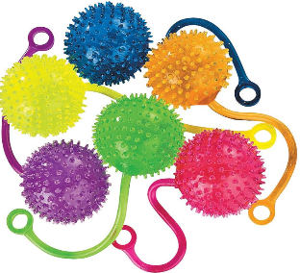

**Yo Yo Balls** are made of brightly coloured plastic, consist of a fluid-filled ball on the end of a ‘rubber string’. There is a risk of strangulation with Yo-Yo Balls as the elastic string part of it stretches when the children swing it, but once caught round the neck it rapidly shortens and can choke a child. The total length of the cord of the yo-yo ball during use must be less than 750 mm.

**Fidget spinners** have become very popular, however, there is a risk of choking among young children due to detachable small parts and/or easily accessible batteries. Make sure these products are labelled with a CE mark, small parts warning and manufacturer’s details.

Some may also present a chemical risk if they contain excess levels of phthalates – buy from reputable suppliers who are able to provide safety information if asked.

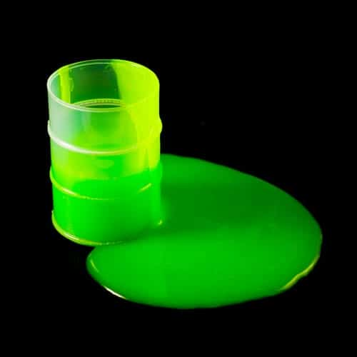**Slime**

The main risk associated with slime is chemical content - some products have been found to contain excess levels of boron. Ensure you are purchasing from a reputable supplier.

**Lasers**

Misuse of lasers can temporarily blind or dazzle persons. Only lasers that are rated Class 1 and Class 2, with a power level up to 1 milliwatt are considered suitable for use by the public. The class marking will be on the packaging. Lasers that are Class 3 or Class 4 or with no classification markings are deemed to be dangerous and must not be sold.

**Magnets**

There have been a growing number of cases where children and teenagers have suffered serious internal injuries after swallowing small magnets found in products such as drink charms, children’s toys or fake piercings. When swallowed, these magnets can pull together causing serious and even life-threatening damage to the digestive system.

Check the packaging and the instructions for use of magnetic sets with small magnets carry the appropriate warnings.

**Bling Dummies and Bling Dummy Clips**

Small ‘gems' attached to brightly coloured dummies, bottles and other baby products can easily fall off and could easily choke a baby or small child. You must ensure any such products you are selling are safe, for example ensure they are supplied by a reputable company who is carrying out safety testing.

**Jewellery**

You must ensure jewellery you supply is compliant and safe.

If you are purchasing any jewellery products, including raw materials and completed products, ensure your supplier can provide information to show compliance. This can include:

* Manufacturer details including their name and address
* Traceability information from the manufacturer
* Test reports detailing the chemical levels of Cadmium, Nickel and Lead (where applicable)

For products you are manufacturing you must ensure your finished product is safe for use, labelled correctly, and your documentation maintained.

Environmental Health NI Have produced guidance for local jewellery manufacturers which is available on the Lisburn & Castlereagh City Council website at [Product safety - lisburncastlereagh.gov.uk](https://www.lisburncastlereagh.gov.uk/w/product-safety)

**Cosmetic Products**

A cosmetic product is any substance or mixture intended to be placed in contact with the external parts of the human body or teeth with a view exclusively or mainly to cleaning them, perfuming them, changing their appearance, protecting them, keeping them in good condition or correcting body odours. Products should not cause damage to human health when applied under normal use.

Cosmetic product labels must include the name and address; weight or volume of the product, its durability and date of minimum durability; a batch code for traceability, product function (if it is not obvious) and a list of ingredients.

The responsible person must keep a Product Information File which contains information on how safe a cosmetic product is for human health.

If you are making cosmetic product, you must notify the Cosmetic Products Notification Portal (CPNP) when selling products within the European Economic Area AND Submit cosmetic product notifications when selling cosmetics to the UK.

Guidance for businesses on Cosmetic product requirements is available from the Office of Product Safety & Standards at [Cosmetic Products Enforcement Regulations 2013 - GOV.UK](https://www.gov.uk/government/publications/cosmetic-products-enforcement-regulations-2013)

**Electrical Goods**

Electrical products that you supply mustbe safe. To help you identify a safe product, ensure you are purchasing all your electrical goods from reputable suppliers and look out for the following:

* Items are marked with the manufacturer's brand name or trademark (this can be on the packaging)
* They bear a CE mark – which may be accompanied by a UKNI Mark
* Provide appropriate warnings and instructions
* Provide technical information such as rated voltage/voltage range, nature of supply, rated power output, IP number

Domestic main powered appliances should only be fitted with a standard 3 pin plug. There are a few exceptions i.e. an electrical shaver, toothbrush which may be fitted with approved three pin conversion plug.

**Candles, Diffusers and Wax Melts**

The laws around the manufacture and supply of candles can be complex and technical, but they exist to ensure that consumers receive adequate warnings and instructions for use; are protected from inhaling or touching harmful chemicals; ensures goods being sold are legal, safe and accurately described, while also ensuring fire risks are minimised.

The exact labelling duties of candles and wax melts will depend on the composition of the mixture, so you will need to consider formulations and quantities on a case-by-case basis.

A UFI number is required for any mixtures classified for any health or physical hazard and falling under the scope of the CLP Regulation.

Candles that imitate foods are not permitted. These products look like food but are not in fact edible. Candles should not have the form, odour, colour, appearance, packaging or labelling that people, particularly children may mistake with food posing a risk of choking, strangulation, or poisoning.

Environmental Health officers in NI Have produced guidance for local makers of Candles, Wax melts and diffusers which is available on the Lisburn & Castlereagh City Council website at [Product safety - lisburncastlereagh.gov.uk](https://www.lisburncastlereagh.gov.uk/w/product-safety)

**Children’s clothing**

To prevent injury and possible strangulation in children, regulations have been made to prohibit the sale or possession for sale of a child’s outer garment with a hood, where a cord is fitted. Hood cords or drawstrings on children’s clothing pose a risk of strangulation in younger children or entrapment resulting in potential severe injuries.

There must not be drawstrings or cords on clothing for children aged 0-7 years, and, for children aged 7-14 years drawstrings must have no free ends and cords must be a maximum length of 75mm.

Children are particularly vulnerable wearing clothing that can burn if accidentally ignited by a naked flame or significant heat source. Children’s dress up costumes and nightwear must meet the relevant flammability requirements.

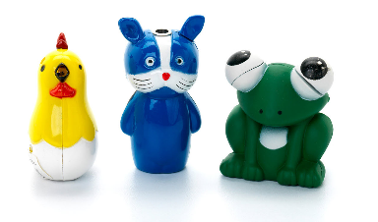**Cigarette lighters**

Lighters can only be placed on the market if they are child resistant.

It is illegal to sell or supply novelty lighters regardless of child-resistance, as there is potential they could be mistaken for a toy, resulting in burns and fire if misused by children.

**E cigarettes & vapes**

You must not supply e cigarettes or vapes that do not comply with product safety regulations.

E cigarettes must contain a **maximum**

* + tank size of an e-cigarette - 2ml
  + volume of a nicotine-containing refill container - 10ml
  + volume of nicotine- containing disposable e-cigarette - 2ml
  + strength of nicotine-containing liquid if present - 20mg/ml (2%) nicotine

The nicotine liquid **must not contain**

* + vitamins, colouring or prohibitive additives
  + any ingredients which pose a risk to human health

They must contain tamper-evident and child-resistant packaging, as there is a risk of accidental poisoning if they do not have child proof caps; and they should be protected against breakage and leakage - including during refill.

The label must contain a health warning that nicotine is highly addictive, and where it contains an electric charger must be CE marked – remember chargers pose a risk of electric shock & fire.

Always check with your supplier that the products you are offered have been notified to the Medicines and Healthcare products Regulatory Agency (MHRA).

And remember it is an offence to sell nicotine inhaling products, including e-cigarettes, to persons under the age of 18 in Northern Ireland.

Detailed advice for retailers of e cigarettes and vapes is available on the Lisburn & Castlereagh City Council website at [Product safety - lisburncastlereagh.gov.uk](https://www.lisburncastlereagh.gov.uk/w/product-safety)

**Further information**

It is impossible to list all non-compliant products but to keep up to date with the most recent product safety recalls visit <https://www.gov.uk/product-safety-alerts-reports-recalls>

Product Safety advice for businesses

[Product safety advice for businesses - GOV.UK](https://www.gov.uk/guidance/product-safety-advice-for-businesses)

Product safety for businesses: A to Z of industry guidance

[Product safety for businesses: A to Z of industry guidance - GOV.UK](https://www.gov.uk/guidance/product-safety-for-businesses-a-to-z-of-industry-guidance)

Environmental Health NI Guidance for manufacturers of Candles, Wax melts & Diffusers <https://www.lisburncastlereagh.gov.uk/w/product-safety>

Environmental Health NI Guidance for manufacturers of Jewellery <https://www.lisburncastlereagh.gov.uk/w/product-safety>

The Cosmetic, Toiletry and Perfumery Association

<https://www.ctpa.org.uk/>