

**Multifactor Authentication Access to  
iTrent Employee Self Service   
and People Manager**

**November 2024**

**Contents**

1. Introduction **3**

For employees **without** a work email address:

1. **Initial Registration** – How to **register** with Multifactor **4**  
   Authentication on iTrent
2. **Post Registration** – How to **sign in** with Multifactor **6**  
   Authentication on iTrent

For employees **with** a work email address:

1. For employees **with** a work email address: **8**  
   How to sign on using **Single Sign On**

# **Introduction**

To ensure maximum security over personal data, iTrent is secured with Multi Factor Authentication (MFA) software in line with data security legislation.

Employees without a work email address will use iTrent’s in-built multi factor authentication process to access their Employee Self Service (ESS) portal. Please note, in November 2024, the MFA has been upgraded and previous users will need to re-register their authentication device. If you **do not have a work email address**, please refer to **Section 2** below.

iTrent has been configured for Single Sign On, which means for employees with a work email address will access their Employee Self Service directly when they are on a LCCC network or VPN. When not on the network, multi factor authentication is processed through their LCCC Microsoft 365 account. If you **have a work email address,** please refer to **Section 3** below.

1. **For employees without a work email address:  
   Initial Registration – How to register with Multifactor Authentication on iTrent**

The link below is specifically for employees who **do not have a work email address** to access their Employee Self Service Portal.

ESS link - <https://ce0736li.webitrent.com/ce0736li_lss>

When you click the link, you will be presented with two options. The first is for people who have a work email address, so choose the second option ‘A different account’:

Enter your username and password. On your first login, your password will be set to your National Insurance Number.

You will be promoted to change your password.

The next screen will be to set up your Multi Factor Authentication.

Go to the app store on your mobile device and download Microsoft Authenticator.

Click the + sign in the top right-hand corner and then choose Work or School Account:

If you already have Microsoft Authenticator, you can simply open the open the app and click the + sign to add the account.

You will have an option to scan the QR code which will automatically set up the account. If you have difficulty scanning, you can also enter the long passcode shown.

Enter the 6-digit number shown on the verification device and click Continue.

It is recommended you take a note of your recovery code which would make it easier to reset your authentication details if you need to in the future.

Click continue.

You will now be taken into the Home screen of your own ESS Portal.

**PLEASE NOTE:**  All accounts have been defaulted to use Microsoft Authenticator App to generate the verification code as this is the most secure method.  Should you prefer to receive an **email** **with a verification code**(which is more secure than no additional verification step, but less than the Authenticator App), your account settings will need to be changed and you will need to contact the HR LearnWell Team on [LearnWell@lisburncastlereagh.gov.uk](mailto:LearnWell@lisburncastlereagh.gov.uk) before you start the registration process.  SMS verification codes are no longer supported.

1. **For employees without a work email address:  
   Post Registration – How to sign in with Multifactor Authentication on iTrent**

Once you have completed the steps above in Section 2, you can follow the below steps to log in to your ESS.

The link below is specifically for employees who do not have a work email address to access their Employee Self Service Portal. You may have saved this link to your home page or bookmarked it, if not please type the link into the address bar in your browser

ESS link - <https://ce0736li.webitrent.com/ce0736li_lss>

When you click the link, you will be presented with two options. The first is for people who have a work email address, so choose the second option ‘A different account’:

Enter your username and password. You may have saved these details to your phone.

You will then be asked to verify your account. To do this you should either open the Microsoft Authenticator App or log in to your email account if you chose to receive email verification, and retrieve the 6-digit code.

You will be presented with the Verify screen.

Open your Microsoft Authenticator App, or log in to your email account, and retrieve the 6-digit code.

Return to the iTrent screen and enter in the 6-digit code then press continue. You will now be logged into your Employee Self Service.

# **For employees with a work email address: How to sign on to ESS or People Manager using Single Sign On**

ESS Link - <https://ce0736li.webitrent.com/ce0736li_ess>

People Manager Link - <https://ce0736li.webitrent.com/ce0736li_web/itrent_wrd/run/etadm001gf.main>

**Access while on LCCC network or VPN**

If you have a LCCC email address, and you are logging into iTrent via the link on the staff intranet, for either your ESS portal or the Line Manager link, you will no longer need to enter any sign in information. You will be automatically logged in via Single Sign On because you are on the LCCC network or VPN.

Line managers must always be connected to an LCCC Network or VPN to access iTrent People Manager, as this site has a higher security restriction in place since it can access multiple people records. However, you will be able to access your own personal Employee Self Service from anywhere, see below.

**Access to Employee Self Service when not connected to the LCCC network or VPN**

You can still access your iTrent Employee Self Service if you are not connected to a Lisburn Castlereagh Network or VPN. To do this please use the link provided in the iTrent Multifactor Authentication User Guide, or in the email sent to you (this is the same as the link on the Intranet, so can also be saved from there for future access when not connected.)

Once you click the link, you will be presented with the sign in screen shown here.

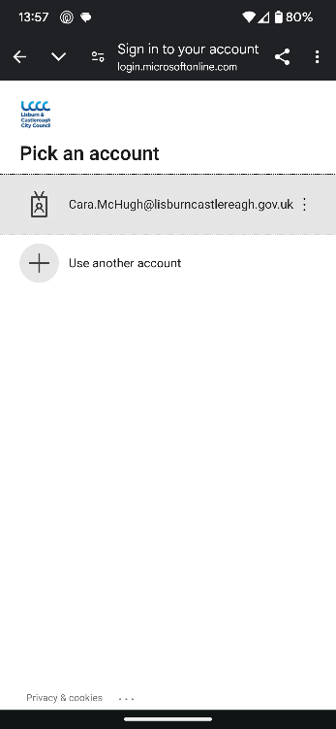

You should enter or choose your Lisburn Castlereagh email address account.

This will take you to a password screen. Enter the password you use to access your work computer and Microsoft 365 account.

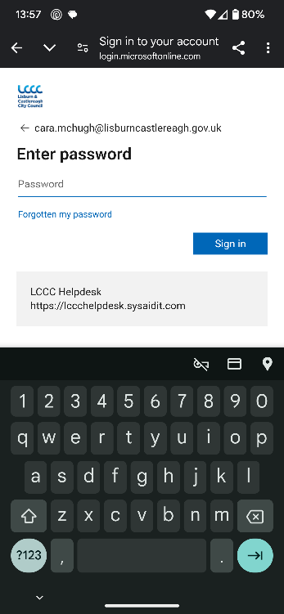

You will have an option to stay signed in so the device will remember you the next time you log in. You should never do this if you are not on your own device and highest security would recommend you don’t stay signed in, even on your own device in case it is lost.

You will then be presented with a 2-digit code, which you will need to enter into your Microsoft Authenticator app.

You will now be logged in to your ESS.