**Candles, Wax Melts**

**& Reed Diffusers**

**Product Safety Information**

**December 2022**

**Introduction and Background**

In Northern Ireland over the last 5 years, statistics indicate that candles played a contributory factor in 130 accidental dwelling fires.

Due to the increase of social networking, such as Instagram and Facebook selling groups, a number of home-based hobbies have turned into a larger operations, often without the candle manufacturer realising they have crossed a line and are running a business where trading and consumer protection legislation applies. All manufacturers need to be aware of their obligations to make sure their products are safe.

The laws around the manufacture and supply of candles can be complex and technical, but they exist to ensure that consumers receive adequate warnings and instructions for use; are protected from inhaling or touching harmful chemicals; ensures goods being sold are legal, safe and accurately described, while also ensuring fire risks are minimised. These duties apply to small scale home-based suppliers in the same way they apply to larger scale manufacturers/suppliers.

This guidance covers:

* Candles - a cylinder or block of wax or tallow with a central wick which is lit to produce light as it burns.
* Wax melts - a completely wick-less scented piece of wax that is melted in a warmer. Reed diffusers - a liquid air freshener in a narrow-necked bottle with long sticks inserted into the liquid.

**General Candle Safety**

Product safety legislation has always required producers and distributors to place only safe products on the marketplace (known as the general safety requirement), provide information and warnings on the risks associated with their products (where these risks are not obvious), and to provide the consumer with instructions on how to use their product safely.

Currently there is no specific law relating to candle safety. However, The General Product Safety Regulations 2005 (GPSR) applies to the overall safety of consumer goods. There are some European Standards which are covered later in this document that provide guidance on how candle safety might be achieved. When a product conforms to these harmonised standards it shall be presumed to be a safe product so far as concerns the risks and categories of risk covered by those standards.

In order to assess safety, it is important that producers know exactly what is in their products and in what proportions; this will also help when it comes to designing compliant labels, and forms part of the technical file under GPSR.

Producers must also take into consideration how children might interact with the products, with any risks identified being mitigated, i.e. using a mould design rather than small parts which could be pulled off and then become a choking hazard. Producers must remember that the use of warnings does not exempt them from legal liability.

**Safety Labelling**

To avoid confusion, Classification, Labelling and Packaging Regulation (CLP) warning labels are one requirement (discussed later in document) and safety labels (such as the symbols seen below) are another. Additional and separate requirement under the European Standards (BS EN 15494:2019 Candles – Product Safety Labels (Indoor candles)), and BS EN 17617:2021 (Outdoor Candles – Product Safety Labels) specifies the format, content and layout of product safety labels for candles.

Although distinct legal requirements, there is no reason why CLP information and European Standards safety information could not be combined onto one label with some thought and attention to detail.

Prior to developing a product safety label able to comply with these standards, it is important that you assess the risks with each product, this will help you identify the supplementary safety information which will be needed as a control measure on the label. Key to this exercise is

* evaluating the remaining residual risks after protective steps have been taken in the design and screening of hazards.
* determining which of these hazards shall be addressed with the use of safety labelling.

All information supplied with a candle must be presented in a clear format and should be easily and nonverbally comprehensive. Such warnings must be visible/legible on the product or packaging - if space is limited peel-off or fold-out solutions may be used.

For many products, all foreseeable hazards resulting from the use and possible misuse of the product cannot be warned about in the form of safety labels. Information overload in the form of too many product safety labels should be avoided. Choices shall be made concerning which hazards pose the greatest risk and require relevant information to be provided on a safety label.

As a minimum, the product safety label with the mandatory supplementary safety information shall be visible and legible on the packaging or product. If space is limited, the optional supplementary safety information can be placed elsewhere, e.g. on the backside of a peel-off label or the inner sides of a fold-out label, together with the mandatory supplementary safety information repeated. There shall be clear indication where to find this additional safety information.

**Layout of the product safety label (both indoor and outdoor candles)**

The product safety label for candles consists of the following components:

1. General Warning Sign (yellow diagram below)

2. Mandatory supplementary safety information symbols or texts

3. Optional supplementary safety information symbols or texts

**1. The General Warning sign**

This must be included in all labelling, in distinct contrast from its background, preferably using this coloured graphic, but for candle labels with one-colour print, the background does not need to be yellow.



**2. Mandatory supplementary safety information symbols or texts**

Any supplementary safety information, symbols and text shall be placed in close proximity to the general warning sign.

Under the standard these safety messages are **mandatory in all cases**:

Depending on the candle type these mandatory symbols may also be required:

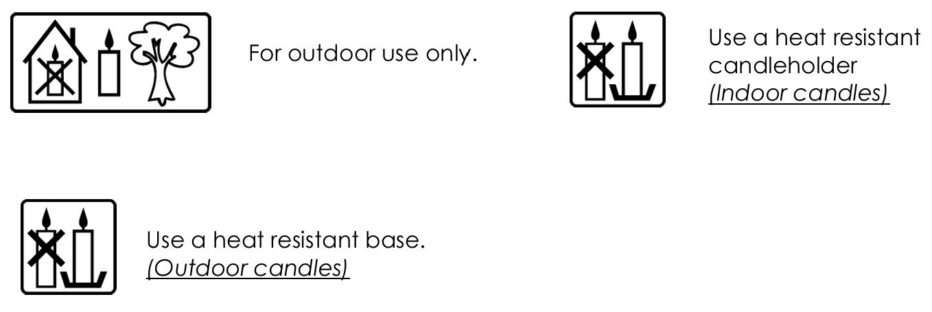

Floating candles:

Specific for grave lights:

Specific for container candles that do not comply with the wind resistance requirement of EN 17616:2021, 4.1.2:

The messages may be given using the pictograms or text or both. If text is used, it must be in the language of the country where the candles are being sold. Environmental Health Departments would advise, where space allows using both the pictorial warning and associated text, to avoid any misinterpretation or lack of understanding from the pictorial warnings alone. The minimum height of the safety symbols is 5 mm provided that the content of the safety message is legible, but use of a larger size is encouraged.

**3. Optional supplementary safety information symbols or texts**

There is additional safety information which is not mandatory but should be selected for each product based on dedicated risk analysis for each specific candle type. These symbols/texts are applicable to both indoor and outdoor candles.

These symbols/texts are applicable to both indoor and outdoor candles.

Keep candles at least x cm apart. (x represents the minimum safety distance between candles and is defined by you)

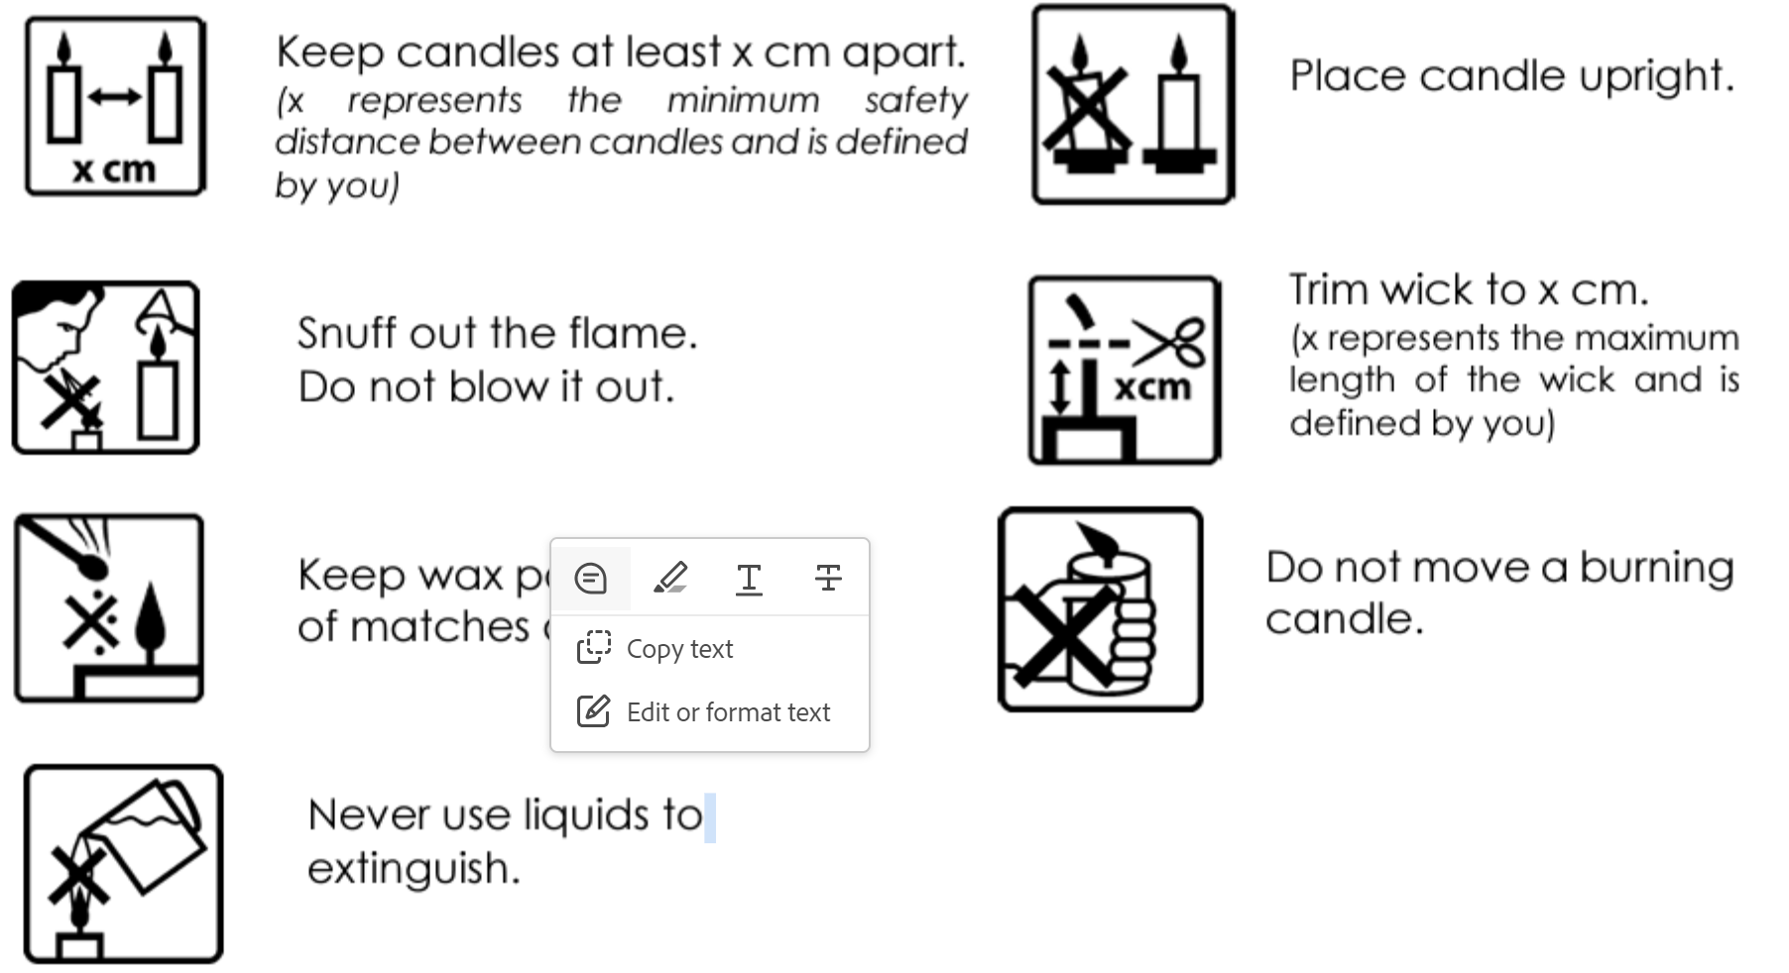

**The supplementary safety information symbols or texts symbols below are applicable to Indoor Candles BS EN 15494:2019:**

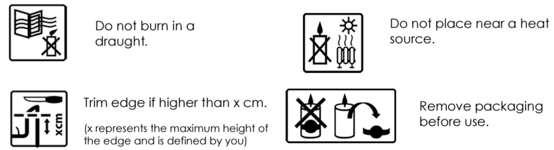

**The supplementary safety information symbols or texts symbols below are applicable to Outdoor Candles BS EN 17617:2021:**

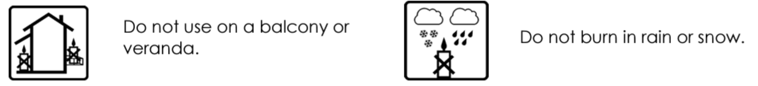

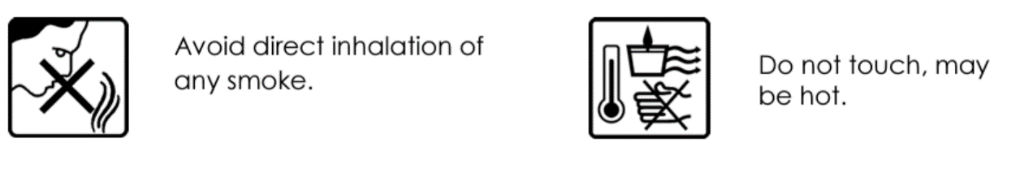

**Additional optional supplementary safety information:**

There are additional optional safety requirements specific to product category such as tea lights, votive candles, container candles and candles not appropriate to use in a warming unit, e.g. scented tea lights.

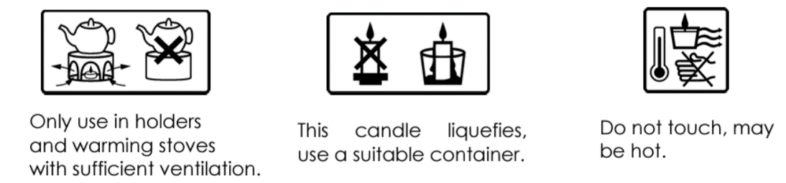 Tea lights: Votive candles: Container candles:

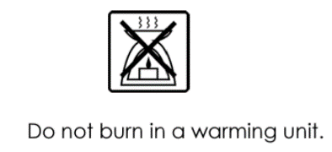

Candles not appropriate to

use in a warming

unit e.g. scented tea lights:

Specific for grave lights

without lid:

Specific for garden torches:

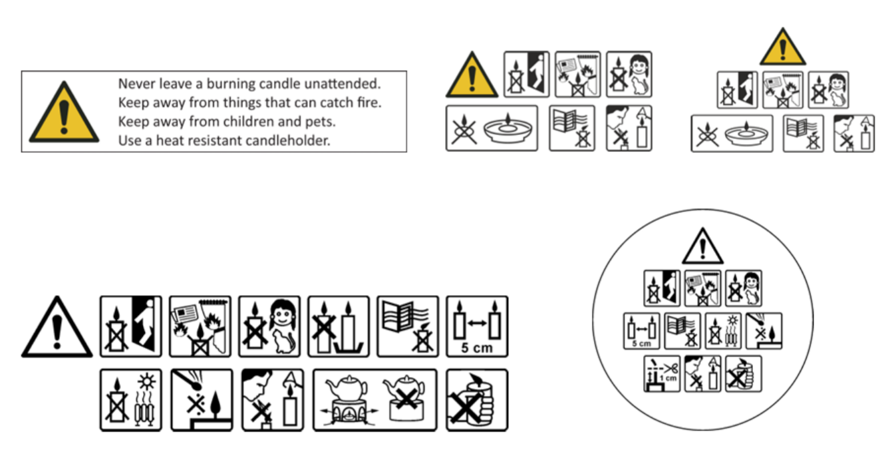

**Examples of product safety labels layout on candle safety - Indoor candles**

**Examples of product safety labels layout on candle safety - Outdoor candles**

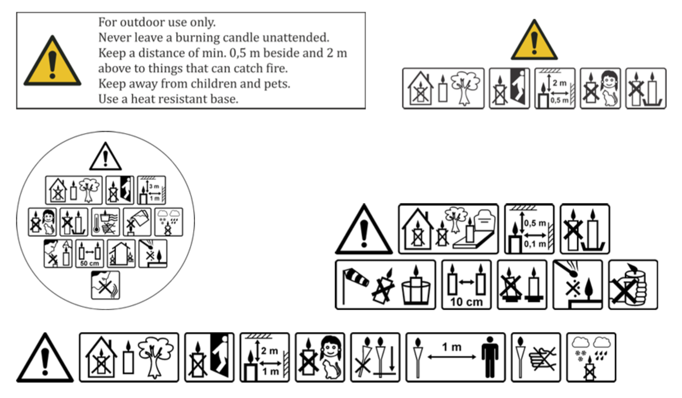

**Other European Standards relating to candle safety:**

There are 3 other standards for candles which cover fire safety and the sooting behaviour of indoor candles and fire safety of outdoor candles. It is within these documents that the requirements and test methods are specified. They also cover safety requirements in relation to stability, secondary ignition, flame height, self-extinguishing and behaviour after extinguishing.

**BS EN 15493:2019 - Candles – specification for fire safety (indoor candles), and**

**BS EN 17616:2021 - Outdoor candles — Specification for fire safety**

Both of these standards specify the requirements and test methods for the fire safety of candles intended to be burned.

It covers the following safety requirements:

* Stability - freestanding candles, container candles and candles that are sold together with a holder or other accessories shall not tip over when tested on a slope (10 ± 0,2)° from level.
* Secondary ignition - no secondary ignition shall occur for more than 10 seconds, when the candle is burning.

The indoor standard also covers:

* Flame height - the flame for all indoor candle types, except tea lights, shall not exceed 75mm. The flame height for tea lights shall not exceed 30mm.
* Self-extinguishing
  + To prevent the ignition of the surface underneath, freestanding candles marketed as self-extinguishing shall self-extinguish at the end of the burning time. The candles shall neither burn a paper placed underneath nor cause any scorch marks on it during the whole burning test.
  + To prevent the ignition or cracking of a supporting holder, non-freestanding candles marketed as self-extinguishing shall self-extinguish at a residual height of ≥ 12mm in case of candles with a diameter of ≤ 14mm and at a residual height of ≥ 18mm in case of other candles.
* Behaviour after extinguishing
  + After extinguishing the candle shall not spontaneously re-light.
  + The wick shall not continue to glow or smoke for an average time of more than 30 seconds after extinguishing.

The outdoor standard also covers:

* Garden Torches - set up and stability and no secondary ignition. Also no burning or smouldering material shall fall from garden torches and the garden torch shall neither burn paper placed underneath nor cause any scorch marks on it during the whole burning test.
* Floating candles - no spontaneous re-lighting after extinguishing.

Further detail on the test methods, etc. are given in the standards, copy available at: <https://bsol.bsigroup.com/>

**BS EN 15426:2018 - Candles – specification for sooting behaviour**

This document specifies the requirements and the test method for evaluating the sooting behaviour of burning indoor candles. It is applicable to single wick candles with a diameter up to 100 mm or equivalent cross-sectional area intended to be burned indoors.

Soot is the solid, carbon enriched particles, which is produced when the base material is incompletely burned in the flame and which are subsequently released into the atmosphere. The soot index is the index number for the evaluation of the sooting behaviour of candles and sooting behaviour is the average soot index per hour from three tests (samples) and this shall be less than 1.0 per hour. The test shall be carried out on finished candles representative of the finished product intended to be supplied/sold. To ensure compliance you should refer to the relevant standard and review the full list to identify the information applicable specific to your product. <https://bsol.bsigroup.com/>

**Technical File**

The General Product Safety Regulations 2005 (GPSR) provide the main basis for ensuring the safety of consumer goods by imposing certain controls. These ensure that all products intended for or likely to be used by consumers under normal or reasonably foreseeable conditions are safe.

As a manufacturer, own-brander or importer of consumer goods (all of which are termed a 'producer' under the Regulations) you will have certain obligations, including traceability and monitoring requirements.

You should keep files of essential information relating to your product formulations. Such records have to be kept for a minimum of 10 years. These records may be electronic. This documentation could contain the following information:

* A description and formula for each product in your range
* Raw material purchase records
* Finished product sales records
* Risk assessments
* Safety Data Sheets (SDS)
* Labelling/packaging details
* Unique Formulation Identifier (UFI)
* Safety testing plan including sample results
* Traceability documents
* Customer complaints and recall procedures.

Technical files must be made available for inspection by ‘market surveillance authorities’ such as Environmental Health Officers from Local Councils (Article 19, EU Reg. 765/2008 and Article 14 Regulation 2019/1020).

**Safety testing**

For larger producers with the skills, knowledge and equipment to do so, most safety testing is conducted in-house following a quality management system, including GPSR requirements and testing against the 5 relevant European Standards covered above.

Smaller producers may need to submit product samples for external laboratory testing where the burning characteristics can be assessed under a series of controlled laboratory conditions, including burning in a burn-test chamber or ventilation-controlled burn-test room, and using the standard wire mesh cylinder to measure sooting.

Safety testing is scalable, so larger producers are expected to test (and keep records of) more samples. Records and test-house certificates of safety testing should form part of the filed technical documentation. Before releasing a new product on to the market, producers are under a legal obligation to assess it for safety. For products you already have on the market you are advised to have an ongoing monitoring process with periodic random sample safety testing commensurate with adequately addressing the risks. A producer that carries out no safety assessments or testing at all will not have demonstrated due diligence, which means they will have no defence in law if an incident occurs, or a breach is identified.

**Classification, Labelling and Packaging**

The purpose of the Regulation is to ensure a high level of protection of health and the environment, as well as the movement of substances, mixtures and articles.

**Legislation**

Regulation (Ec) No 1272/2008 Of The European Parliament And Of The Council of 16 December 2008 on classification, labelling and packaging of substances and mixtures (CLP). CLP labelling requirements are in addition to the safety labelling under General Product Safety Regulations on Page 2.

**General labelling rules under CLP**

General and specific rules regarding the content and application of a CLP label are set out in CLP Article 31. The CLP Regulation requires that the labels are firmly affixed to one or more surfaces of the immediate container of the substance or mixture and that they must be readable horizontally when the package is set down normally. The label elements themselves, in particular the hazard pictograms, must stand out clearly from the background. Furthermore, all label elements must be of such size and spacing as to be easily read. They must be clearly and indelibly marked. A physical label is not required when the label elements are shown clearly on the packaging itself.

**Elements of the CLP Hazard label**

A substance or mixture such as a candle, melt or reed diffusor containing essential oils or fragrances could be classified as hazardous and must bear a label including the following elements.

* The name, address and telephone number of the supplier
* The nominal quantity (unless this quantity is specified elsewhere on the package) (i.e. the weight)
* Product identifiers
* Hazard pictograms, where applicable
* The relevant signal word, where applicable
* Hazard statements, where applicable
* Appropriate precautionary statements where applicable
* A section for supplemental information, where applicable

Certain labelling exemptions apply e.g. to substances and mixtures contained in packaging that is small (typically less than 125 ml) or is otherwise difficult to label. You can find more information regarding this on page 43 [https://echa.europa.eu/documents/10162/23036412/clp_labelling_en.pdf/89 628d94-573a-4024-86cc-0b4052a74d65](https://echa.europa.eu/documents/10162/23036412/clp_labelling_en.pdf/89%20628d94-573a-4024-86cc-0b4052a74d65)

**Product Identifier (Name)** - This is the name of your product; you could use the fragrance name i.e. "Chocolate Orange candle" or name it something more unique "Velvet Chocolate & Orange Candle". For more information (Article 18(2)) and (Article 18(3)) of the CLP REGULATION (EC) No 1272/2008

**Signal Word** - Words such as "Warning" or "Danger", these will be triggered depending on the Hazard statement that may be triggered. A signal word indicates the relative level of severity of a particular hazard. The label must include the relevant signal word in accordance with the classification of the hazardous substance or mixture: more severe hazards require the signal word ‘Danger’ while less severe hazards require the signal word ‘Warning’. For more information Article 20 of the CLP REGULATION (EC) No 1272/2008

**Hazard (H) Statements** - A hazard statement is a phrase that describes the nature of the hazard in the substance or mixture. A hazard statement will be determined by the application of the classification criteria.

Examples of hazard statements include:

* Causes serious eye damage.
* Toxic if swallowed.
* Toxic to the aquatic life with long lasting effects.

**Precautionary (P) Statements** - A set of instructions that advise the user how to avoid or minimise the hazards that may be caused by the hazardous mixture.

Examples include:

* IF ON SKIN: Wash with plenty of soap and water.
* Avoid release to the environment.
* Wash hands and other contacted skin thoroughly after handling.

Product Identifier (Substances) - Article 18(3) of CLP provides that the identity of all substances in a mixture that contribute to the classification of the mixture in certain hazard classes must be given on the label. A maximum of four chemical names are to be included, unless more are needed to reflect the nature and severity of the hazards. Pictograms - Pictograms are a specific warning image designed to correspond to every relevant H Statement. Hazard Pictograms. A hazard pictogram is a pictorial presentation to communicate information on the hazard concerned, see also the definition provided in Articles 2(3) and 31(2) of CLP. According to CLP Article 19, the classification of a substance or mixture determines the hazard pictograms that have to be displayed on a label.

Further information on labelling and packaging is available at <https://echa.europa.eu/documents/10162/2324906/clp_labelling_en.pdf/89628d94-573a-4024-86cc-0b4052a74d65>

**Hazard pictograms**

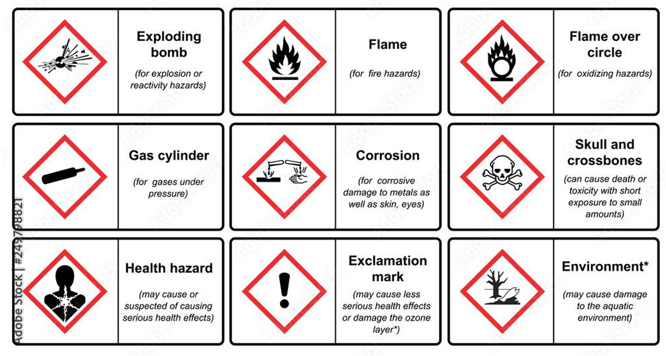

**Packaging**

Article 35 of CLP includes the requirements for packaging containing hazardous substances or mixtures. These provisions are to ensure that:

* The packaging is designed, constructed and fastened so that the contents cannot escape.
* The materials of the packaging and fastening are not damaged by the contents and are not liable to form hazardous compounds with the contents.
* The packaging and fastenings are strong and solid throughout to ensure that they will not loosen.
* Packaging fitted with replaceable fastening devices is properly designed to allow repeated refastening without the contents escaping.
* The packaging does not attract or arouse the curiosity of children or mislead the consumer when supplied to the general public.
* The packaging does not have a similar presentation, or a design used for foodstuff or animal feed stuff or medicinal or cosmetic products which would mislead the consumers.

**Child-resistant fastenings and tactile warnings**

If you supply substances and mixtures to the general public, you may have to fit child-resistant fastenings (CRFs) and/or tactile warnings of danger (TWDs) to your packaging (Part 3 of Annex II to CLP). These provisions are triggered by either a specific hazard class/category or by the concentration of specific substances. These provisions apply whatever the capacity of the packaging.

**Additional CLP information**

The concentration of the fragrance within the candle will also affect the statements needed, so a candle with 5% fragrance may need a different label from a candle using the same fragrance at 10%. If the candle is not classified (i.e. it DOESN’T contain any ingredients that are classified as hazardous) then there is no requirement for it to be labelled in accordance with CLP. The chemicals that have to be listed on a label are the ones listed in section 3 of the Safety Data Sheets (SDS) which are provided by the supplier of the raw ingredients.

**Safety Data Sheets**

Safety Data Sheets (SDS) are a safety document that determines ingredients in a particular mixture (e.g. a fragrance oil). It contains contact details of the supplier and other important safety information including potential hazards, information on handling and storage as well as emergency measures in the case of an accident.

Selling directly to consumers does not require producers to supply a SDS to them; the label will provide all the consumer information required. If producers are not directly supplying the end user, then an SDS will have to be compiled and provided to the retailer/professional for each formulation that is supplied if a mixture has hazardous properties or where it contains certain hazardous components above specified concentrations (as defined in CLP).

The applicable legislation for SDS is Article 31 of REACH available on the European Chemicals Agency (ECHA) website; <https://echa.europa.eu/legislation>

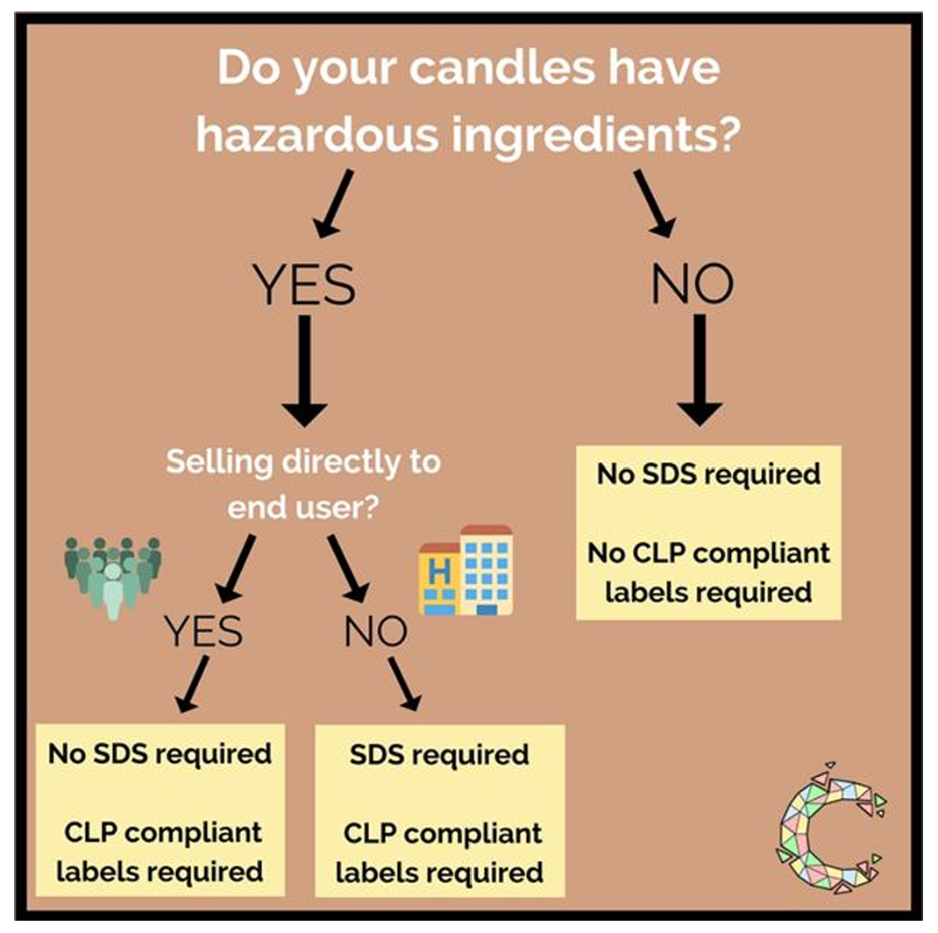

**Unique Formulation Identifier- (UFI)**

Chemicals (substances or mixtures) placed on the market must comply with the EU CLP Regulation Article 45 & Annex VIII. Since January 2021, CLP requires all new consumer chemical-containing products with hazards to have a Unique Formulation Identifier (UFI). Therefore, candles etc. which have been classified as hazardous under CLP require a UFI. The acronym ‘UFI’ must be in capital letters then a colon and be followed by a 16-character alphanumeric code e.g. ‘UFI: HUF0-F02Y-8001-UV1E’. You may benefit from a transitional period for products you have already notified and which are already on the market. Such notifications will remain valid until 1 January 2025 or until changes are made to the product (e.g. changes to the mixture composition, toxicological properties or product identifiers).

The UFI codes can be generated by visiting the ECHA Poisons Centre website: <https://poisoncentres.echa.europa.eu/ufi-generator>

Notification must be sent to the National Poisons Information Services, Birmingham.

Additional information on CLP requirements is available at: [https://echa.europa.eu/documents/10162/2324906/clp_labelling_en.pdf/896 28d94-573a-4024-86cc-0b4052a74d65](https://echa.europa.eu/documents/10162/2324906/clp_labelling_en.pdf/896%2028d94-573a-4024-86cc-0b4052a74d65)

**Traceability**

Producers should mark their products with a product reference (a code or name for your candle) and/or its production batch to ease traceability. Production records should be kept for each batch which can be used to identify the source of components in the product in the event of an unsafe ingredient being identified. Supply records for each batch should also be kept to complete the traceability chain, especially in the event of an unsafe product being identified.

There is no 'line of sight' requirements for the batch number. Some producers base the batch number on the date of production. A corresponding record should be kept in the technical file.

In addition, the label should also indicate your details including your business name and geographical address.

A producer is also required to keep and provide documentation necessary to trace the origin of products which can be used to trace an unsafe product back to its source.

**Unsafe Products & Product Recalls**

You need to provide consumers with adequate information so they can use the product safely. Adequate safety labelling as detailed above in the sections on Safety Labelling must be provided. If at any point you become aware that a product you have placed on the market, or have supplied, “poses risks to the consumer that are incompatible with the general safety requirement” then you have a legal duty to immediately notify your local Environmental Health Department who will advise you on what you need to do and will help you assess the risk and the appropriate response as well, as ensure the Government notification duty is correctly followed. If the risk is deemed to be serious and affects more than one market they will generate a serious risk notification to the Commission - Safety Gate but also on the Product Safety Database, as NI is also in the UK Internal Market, and discuss recall procedures with you.

Under General Product Safety Regulations (GPSR) you are required to have sufficient “measures” in place to, if necessary, effect a product recall, and we advise you to be aware of your legal notification, risk assessment and recall obligations before an event occurs. You therefore need to prepare a procedure which can be added to your technical file. It will allow for a faster response time when an incident occurs. It will be your responsibility to carry out any programme of corrective action or product recall. As part of your due diligence, you will need to review all customer feedback and complaints

Guidance to assist with putting together a product safety incident plan (PSIP) can be found PAS 7100 Code of practice on consumer product safety related recalls and other corrective actions, which can be downloaded for free from the BSI website.

**Imitation Foods**

Candles, wax melts or diffusers which could be mistakenly eaten by children / vulnerable adults or present a choking hazard are subject to the Food Imitations Safety Regulations 1989. Examples would be candles with the same shape or smell as fruit, sweets, chocolates or cakes.

These Regulations prohibit the marketing, importing and manufacture of products that look like foodstuffs but that are not in fact edible. In particular they prohibit the supply of goods that have one or more of the following: form, odour, colour, appearance, packaging, labelling, volume, that children / vulnerable adults could confuse with food and put in their mouth or suck or swallow, which may cause death or injury. Injury can include choking, strangulation, cutting, poisoning, or even causing a child to vomit. This provides a fairly blanket ban on candles resembling food.

Under CLP, chemical-containing products must not be supplied in a shape or design that attracts the active curiosity of children, or misleads consumers, or look like packaging for food, medicines, or cosmetics.

In order to assess whether a candle can cause injury or a risk to health any appropriate harmonised European standard could be used. The EN 71 series of standards covers the safety properties of toys and would be suitable to assess, for example, whether a food imitation candle releases a small part that could cause a choking hazard.

The following are examples of products that have been deemed to be food imitating and could cause injury or harm to health.

Due to its presentation, the product can easily be confused with a bunch of grapes. The grapes break off and are a choking hazard.

Due to its presentation, the product can easily be confused with a soft drink. It may therefore be swallowed from the easily opened bottle by a child or vulnerable person, which can cause gastrointestinal irritation.

Due to its characteristic form, colour, appearance and size, the product may be mistaken for foodstuff. A small part can be easily detached or bitten off the candle. This may lead children to put it in the mouth and choke.

**Misleading Statements and Omissions**

If a manufacturer is making any claims as to the efficiency of the fragrance, burn time or any other marketing claim, they must ensure it can be factually backed up and does not omit material information or mislead the consumer.

**Use of consultants**

Depending on a producer’s level of knowledge and competency, it may become apparent that some expert input from an experienced consultant could help with identifying the ingredients, calculating their quantities and assessing concentrations in the end product. This in turn will help to determine any hazards or risks and contribute to the type of labelling appropriate. In addition to this, an experienced consultant in the candle industry can also advise or assist with safety test methods, technical files, and designing legally compliant labels.

**Further Online Resources**

1. GPSR legislation <http://www.legislation.gov.uk/uksi/2005/1803/contents/made>

2. GPSR Guidance notes <https://www.gov.uk/government/publications/general-product-safetyregulations-2005>

3. The British Candlemakers Federation: Candle Advice Pack: <https://www.britishcandles.org/?pages_id=51>

4. The British Candlemakers Federation - Burn test log: <https://www.britishcandles.org/documents/www.britishcandles.org/Trading_Standards/samplecandleburntestlog(2020).pdf>

5. Candle testing <https://www.youtube.com/watch?v=niZ9Ic5Be2w>

6. Food imitations guidance <https://www.businesscompanion.info/en/quick-guides/product-safety/food-imitations>

7. ECHA Guidance on CLP <https://echa.europa.eu/web/guest/guidance-documents/guidance-onclp>

8. ECHA Guidance on how to classify mixtures under CLP <https://echa.europa.eu/regulations/clp/classification>

9. ECHA presentation on mixture classification- practical application [Title of presentation](https://echa.europa.eu/documents/10162/2198672/05_mixtures_examples_en.pdf/83d5e354-a9e7-4811-9e02-311228e2d91b?t=1415703803873)

10. ECHA mixture classification-exercises [Title of presentation](https://echa.europa.eu/documents/10162/2198672/05_mixtures_examples_en.pdf/83d5e354-a9e7-4811-9e02-311228e2d91b?t=1415703803873)

11. ECHA Guidance on labelling and packaging requirements: <https://echa.europa.eu/regulations/clp/labelling>

12. ECHA Specific labelling and packaging situations CLP – Child resistant fastening or tactile warnings [Specific labelling and packaging situations - ECHA](https://echa.europa.eu/regulations/clp/labelling/specific-labelling-and-packaging-situations)

13. ECHA UFI information [Why the UFI matters for everybody - Poison Centres](https://poisoncentres.echa.europa.eu/why-the-ufi-matters-for-everybody#:~:text=The%20idea%20of%20the%20UFI%20code%20is%20simple.,or%20your%20physician%20on%20correct%20treatment%2C%20if%20any.)

14. ECHA Simplified guidance on REACH Requirements [Guidance in a Nutshell - ECHA](https://echa.europa.eu/support/guidance-on-reach-and-clp-implementation/guidance-in-a-nutshell#:~:text=These%20documents%20explain%20in%20simple%20terms%20the%20main,implications%20for%20them%20of%20different%20aspects%20of%20REACH.)

15. HSENI - REACH explained <https://www.hseni.gov.uk/topic/reach>

16. You Tube – Various industry videos are available