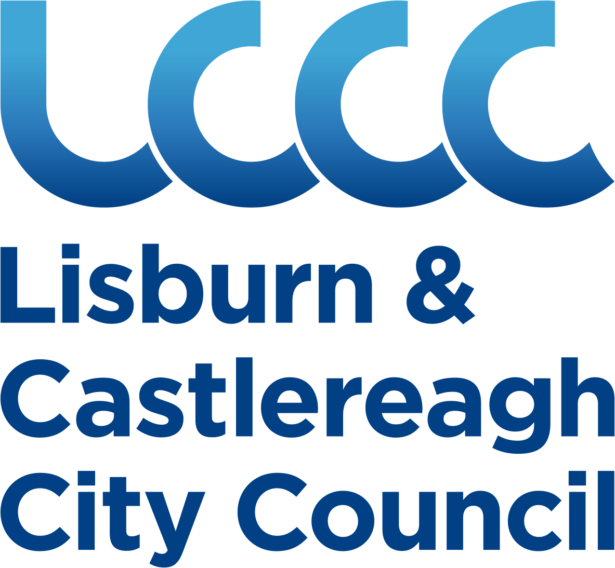

Scoring Matrix for Events funding
From £1,000 - £10,000

Name of Applicant/Organisation/Club:

Title of Event:

Date(s) of Event:

Location of Event:

Does the event meet all the following criteria:

Criteria | Scoring  Matrix | Score Obtained
A/ Attraction of out-of-state visitors and participants to the Lisburn & Castlereagh City Council area. | Pass/Fail
B/ Attraction of domestic visitors and participants to the Lisburn & Castlereagh City Council area. | Pass/Fail
C/ Generation of at least 50 ‘bed-nights’ in the Lisburn & Castlereagh City Council area. | Pass/Fail
D/ Attract at least 1,250 visitors and participants to the Lisburn & Castlereagh City Council area, if government guidelines permit this number at the time of the event. | Pass/Fail
E/ Generation of positive publicity for the Lisburn & Castlereagh City Council area strengthening the areas credibility as a tourist and visitor destination. | Pass/Fail
F/ Attraction of positive media coverage outside the Lisburn & Castlereagh City Council area. | Pass/Fail
G/ Requires Lisburn & Castlereagh City Council assistance to ensure the overall success of the event. | Pass/Fail
H/ Have not received funding during this financial year for another event from LCCC | Pass/Fail
I/Where the main purpose of an event is to raise money for a charity and/or charities, financial assistance will not normally be provided by Lisburn & Castlereagh City Council. | Pass/Fail
Criteria | Scoring  Matrix | Score Obtained
Does the event take place in the Lisburn & Castlereagh City Council area? | Pass / Fail
How many years’ experience do the event organisers have in the management of events? | Year 1 = 1  2 years = 2  3-5 years = 3  6-9 years = 4  10 years+ = 5
How many years has the event been running? | Year 1 = 5  2 years = 4  3-5 years = 3  6-9 years = 2  10 years+ = 1
Is gap funding required? | Pass / Fail
Amount of sponsorship confirmed for the event from 3rd parties? | 0-500 = 5  501-1000 = 4  1001-2500 = 3  2501-5000 = 2  5000+ = 1
How many out-of-state spectators and participants will the event bring to the Lisburn & Castlereagh City Council area? | 001-500 = 1  501-750 = 2  751-1000 = 3  1001-1250 = 4  1251+ = 5
How many domestic spectators and participants will the event bring to the Lisburn & Castlereagh City Council area? | 001-750 = 1  751-1250 = 2  1251-1750 = 3  1751-2250 = 4  2251+ = 5
How many bed-nights will the event generate in the area? | 50-75 = 1  76-150 = 2  151-200 = 3  201-250 = 4  251+ = 5
How will the event generate positive publicity for the Lisburn & Castlereagh City Council area, strengthening it as a tourist and visitor destination? | NI = 1  Ireland = 2  UK = 3  Europe = 4  Worldwide = 5
How will the event generate positive media coverage for the Lisburn & Castlereagh City Council area? | NI = 1  Ireland = 2  UK = 3  Europe = 4  Worldwide = 5
Safeguarding Policy (Child Protection Policy and/or Vulnerable Adults Policy – depending on audience profile) | Yes / No
Health & Safety Policy | Yes / No
Equal Opportunities Policy | Yes / No
Traffic Management Plan | Yes / No
Valid Public Liability Insurance  - Employers Liability Insurance  - Specific Event Insurance (to include cancellation cover) | Yes / No
Has the declaration been signed | Yes / No
TOTAL SCORE OBTAINED

